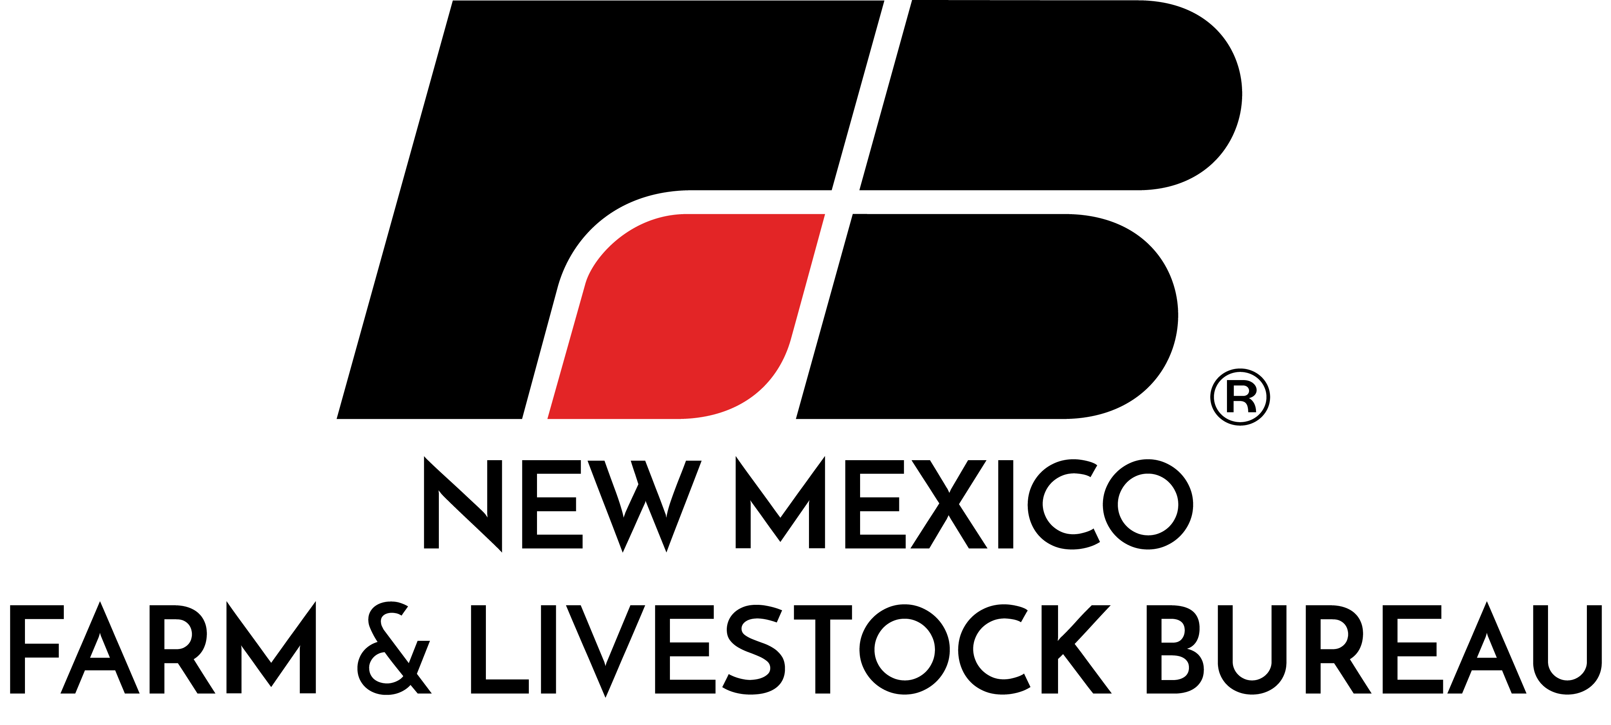

June 3, 2021
Contact:
Dalene Hodnett
(575) 532-4785
daleneh@nmflb.org

NEW MEXICO FARM & LIVESTOCK BUREAU URGES THE
BIDEN ADMINISTRATION TO SECURE THE BORDER
New Mexico Farm & Livestock Bureau joins all 50 state Farm Bureaus and Puerto Rico Farm Bureau in sending a letter today urging the Biden administration to address the surge of undocumented immigrants entering the United States. The increase in illegal immigration is severely impacting farm and ranch families, putting property and personal safety at risk. The letter was sent to Homeland Security Secretary Alejandro Mayorkas, Agriculture Secretary Tom Vilsack and Interior Secretary Deb Haaland.
“For years our farm and ranch families along the southern border have been caught in the middle of a perilous situation that continues to escalate” says Craig Ogden, President of New Mexico Farm & Livestock Bureau. “My heart goes out to those families who have farmed and ranched in that area for generations and are victim to dangerous and sometimes violent, drug and human traffickers. It is not safe to let children play in the yard and border residents are on constant alert that immigrants will break into their homes looking for food and water. We need the administration to recognize that this is not a partisan issue, but an issue of safety for our citizens, swift action should be taken now to protect both citizens and immigrants alike.”
The letter points out that local and state border security resources have been exhausted, leaving little help for farmers and ranchers. It highlights the problem of human smugglers, known as Coyotes, explaining that landowners live in fear while Coyotes reap a windfall from leaving people destitute.
“Human smugglers (Coyotes) are making false promises and doing whatever it takes to get paid and get away, including jeopardizing lives and property,” the letter continues. “In their desperation to evade law enforcement, Coyotes abandon people, steal vehicles, vandalize property and threaten the safety and livelihoods of farmers and ranchers. They are often criminals who smuggle drugs and firearms into the country, frequently leaving them on property, causing unrest for farm and ranch families.” The letter asks the federal government to provide additional resources to secure the U.S. border.
New Mexico Farm & Livestock Bureau, a 20,000 member families organization comprised of farmers and ranchers, and those who are interested in private property rights and a local food supply. NMF&LB is the state’s largest, private agricultural organization and was founded in 1917. For information about joining us, please call 575-532-4703 or visit www.nmflb.org.

Read the full letter here. http://bit.ly/AFBFBorderLetter

###

